A programm conducted on Gender equity on 03/02/2022

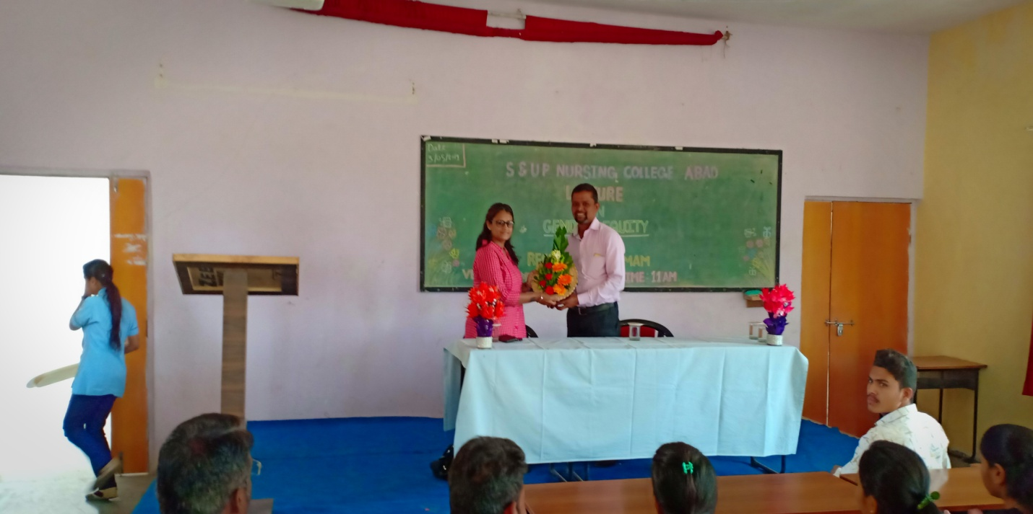
Welcoming a Eminant Speaker Mrs.Resham Bamb founder of SHY Foundation Aurangabad. By Principal Mr.Anvarasab Naregal

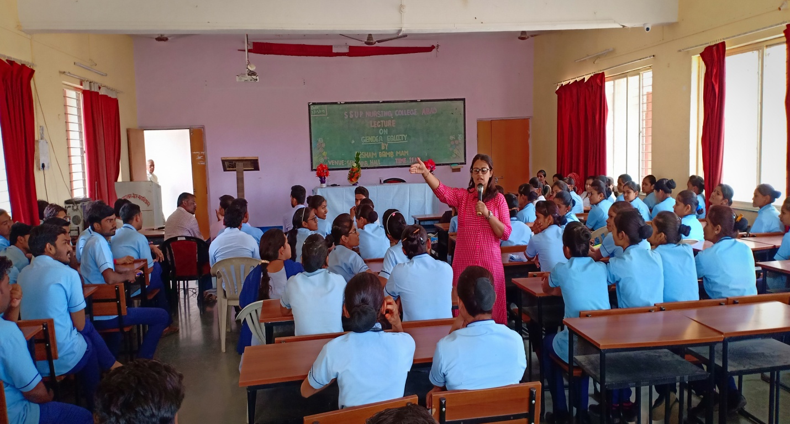
Session by Mrs.Resham Bamb

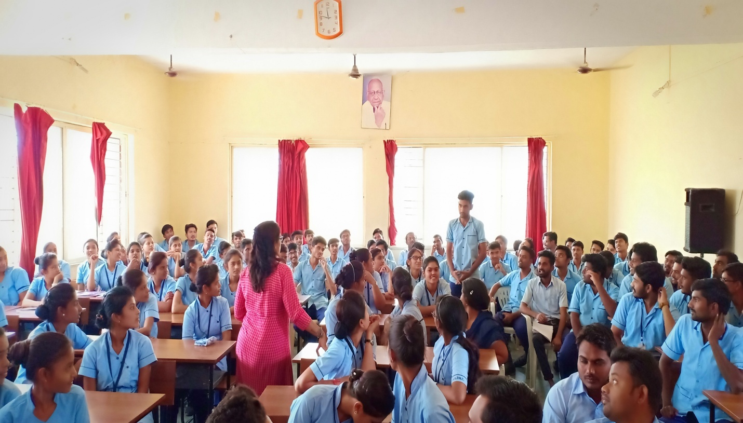
Mrs. Resham Bamb Interacting With The Audience During Session

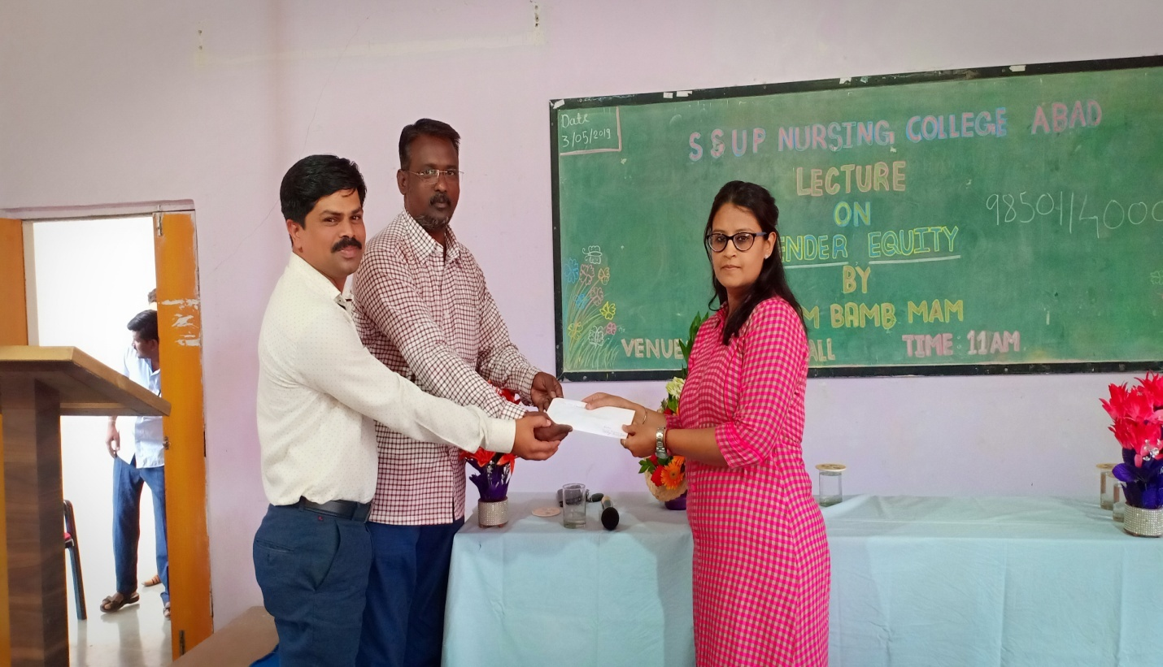
Donation donated to SHY Foundation Aurangabad From the College.

